Genuine Slate Roofing with Reduced Weight: The interlayment installation method
Provider# 40107638
AIAGSS201
aia-course@greenstoneslate.com
Greenstone Slate Company
Provider# 40107638
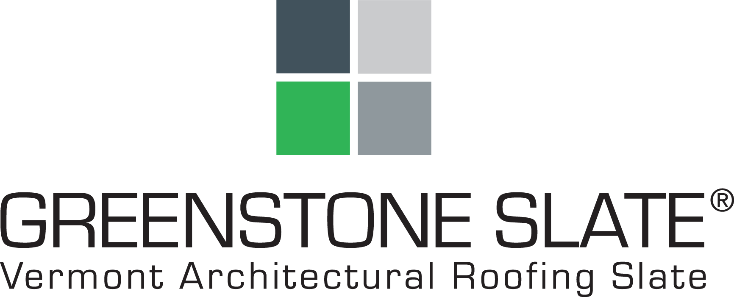
n/a – online course

